**Lab 01 Report**

**Individual Tasks**

*Saitejasree Ramala*

*16172566*

***To access UMKC Cloudera Servers:***

Initially downloaded v464.exe from http://www.umkc.edu/is/support/services/vpn/Windows/ and then connected it to UMKC VPN.

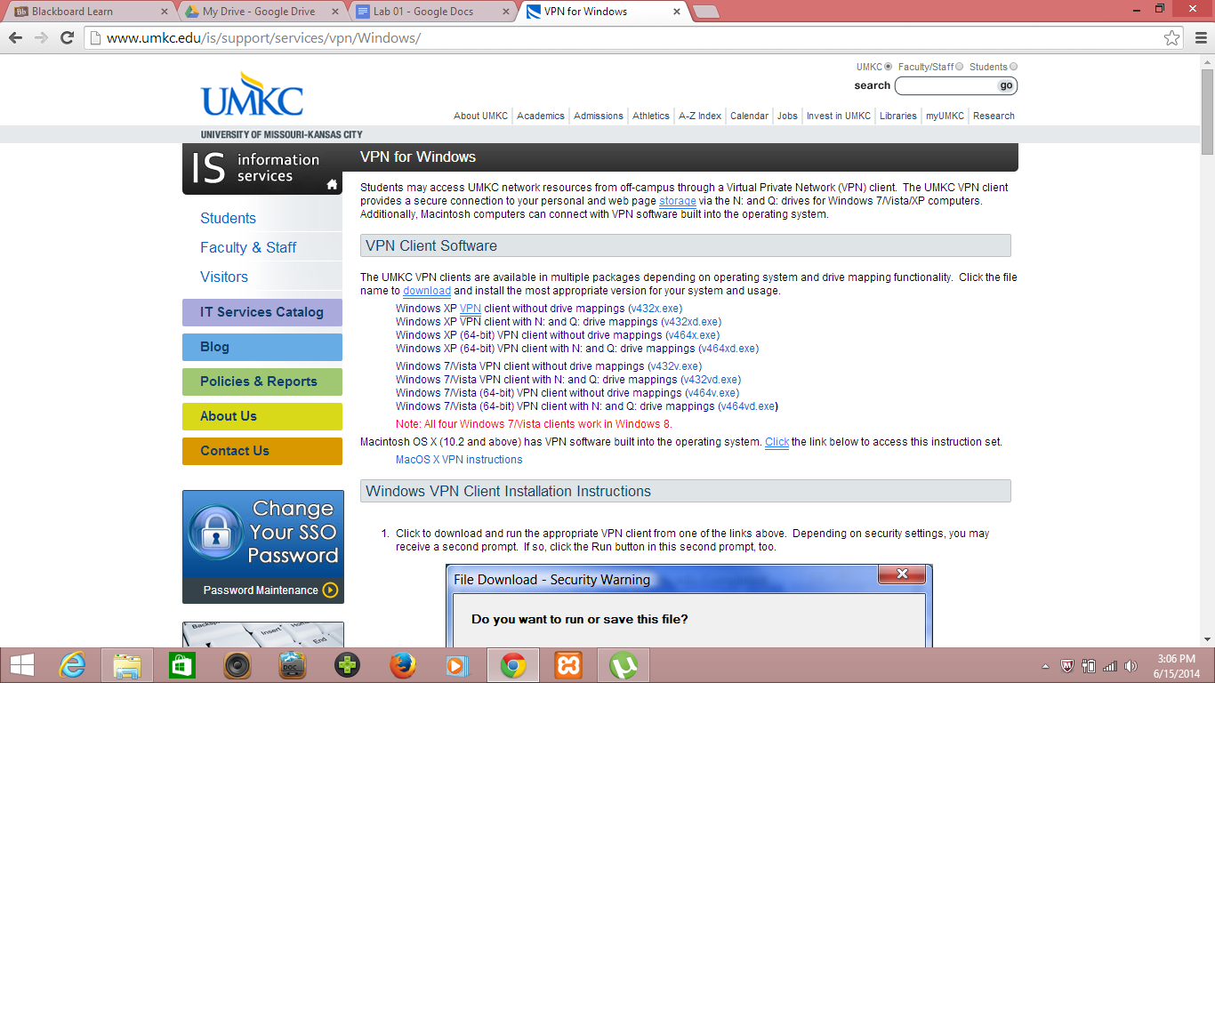

Then installed v464.exe and ran UMKC VPN in order to get connection to UMKC VPN for which I used Group credentials for connecting to School Cloudera Servers.

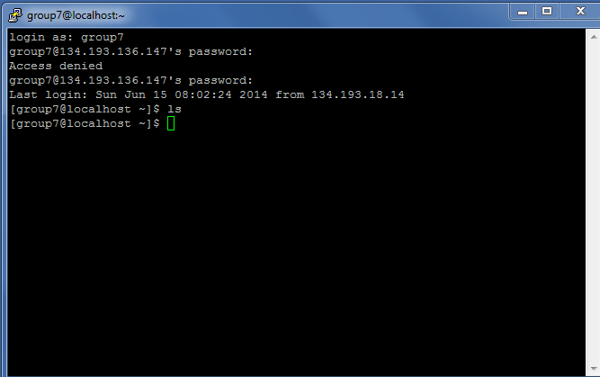

Later, I tried to get connection using my SSO and password but couldn’t get it and the screenshot I got is shown below. Finally, used Putty to execute commands.

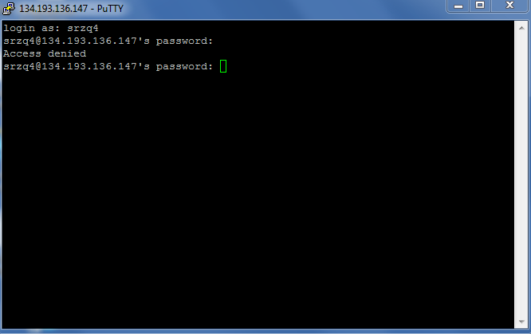

***Installing Cloudera Server:***

Installed VMware player downloaded from the link given in the Tutorial then downloaded Cloudera image for vmware player from the tutorial link.

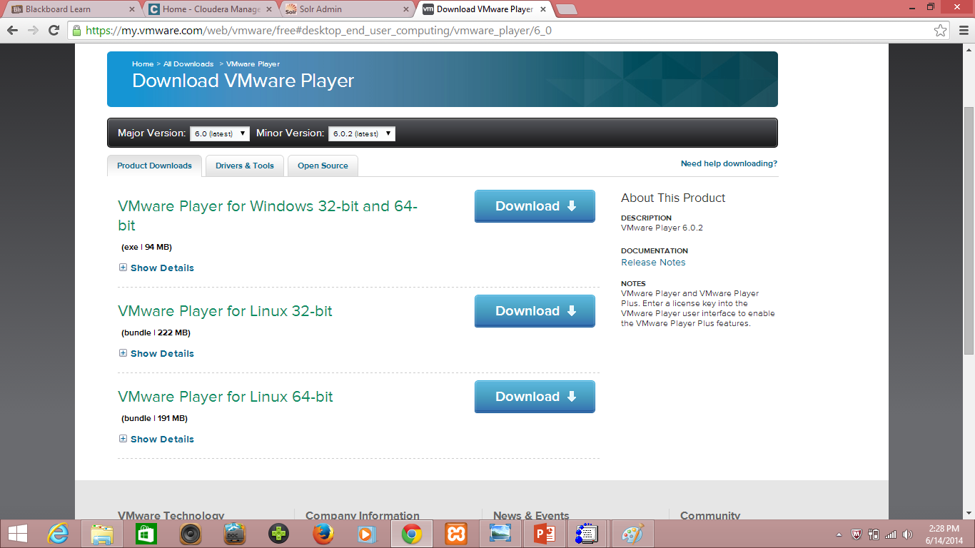

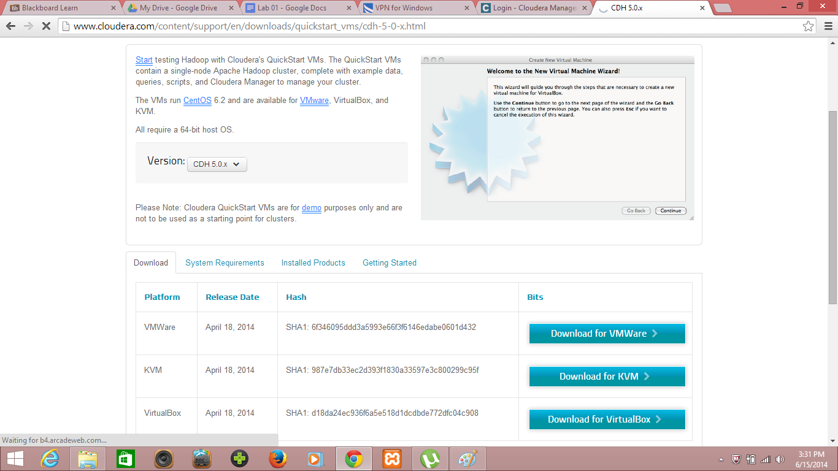

By Changing settings and using virtual box image, installed Cloudera server which is shown below.

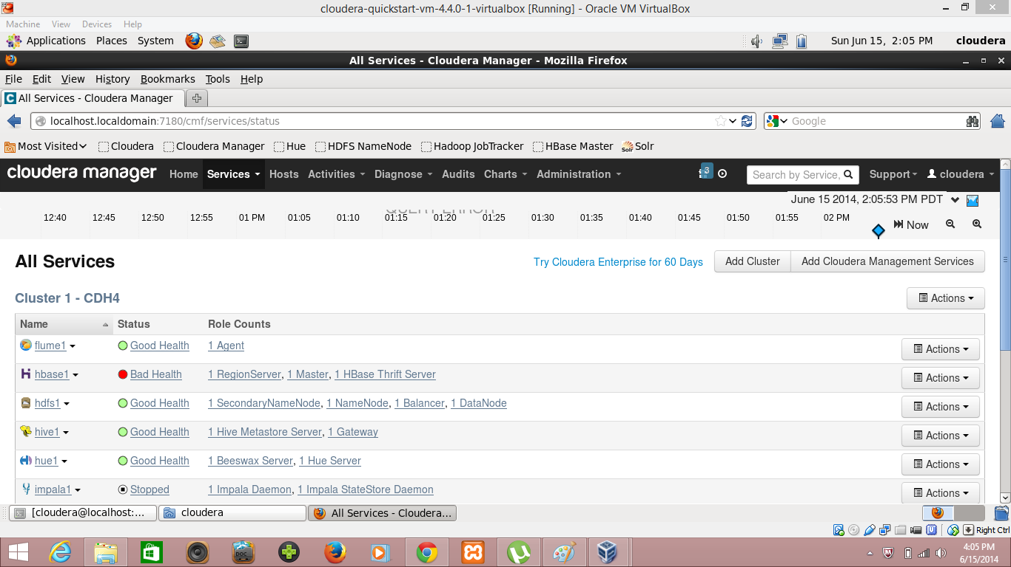

***Transfer Files to Cloudera:***

Firstly, opened FileZilla and then using the host, username, password(used the group details) and port details I successfully established connection and then using the file location transferred one of the files from Local site to Remote site whose screenshot is given below.

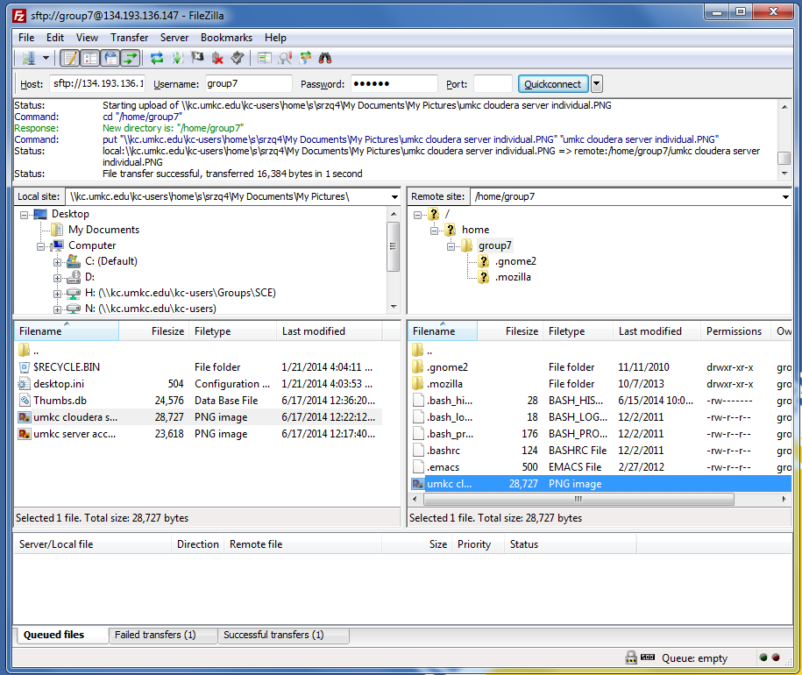

***Run a Program ‘Word Count’ on Cloudera:***

Firstly downloaded the word count source code from the tutorial link and understood the Mapper and Reducer class then extracted the files from it using the given commands. Out of the files, there is a file which consists of a text file called input whose data is sent to another file called ‘teja’ and this ouput file is set as ‘output7’ and this program is run using the command given in the tutorial.

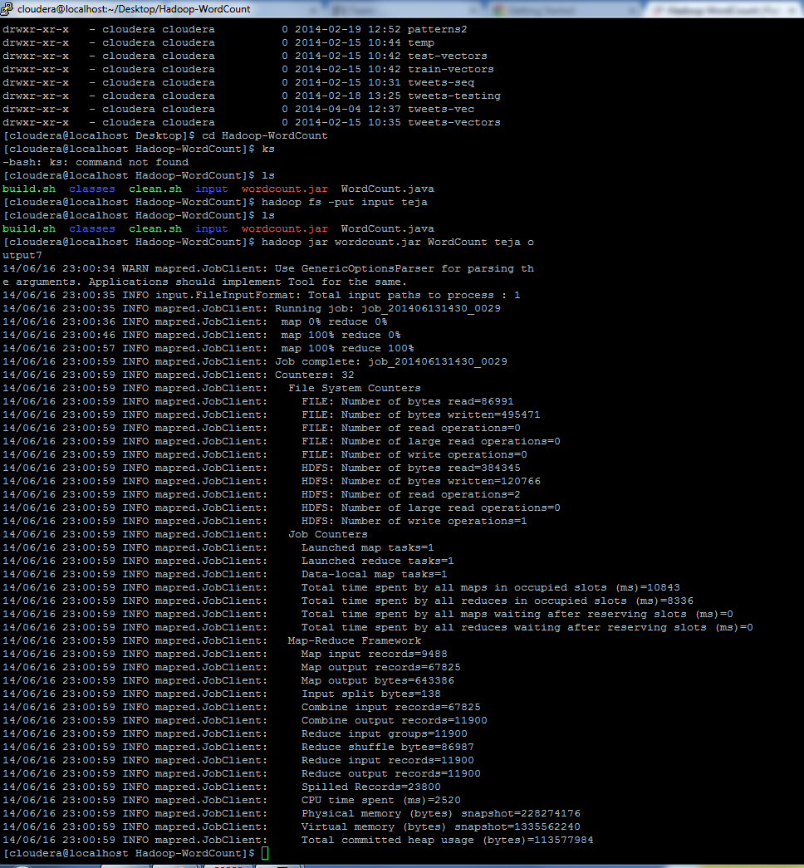

After running the program the output of the word count program is displayed using the command given in the tutorial.

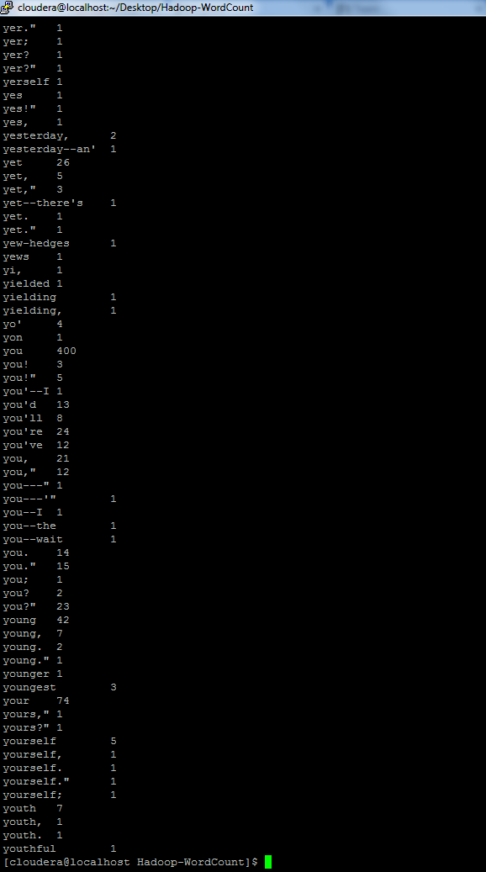

***Make a Hadoop jar and run it in Cloudera:***

Firstly, downloaded the word count program code from the tutorial link then imported the code into my eclipse under hadoop project after which exported that project as jar file sown below.

Then ran the word count exercise jar file and got the same results as for the word count example.

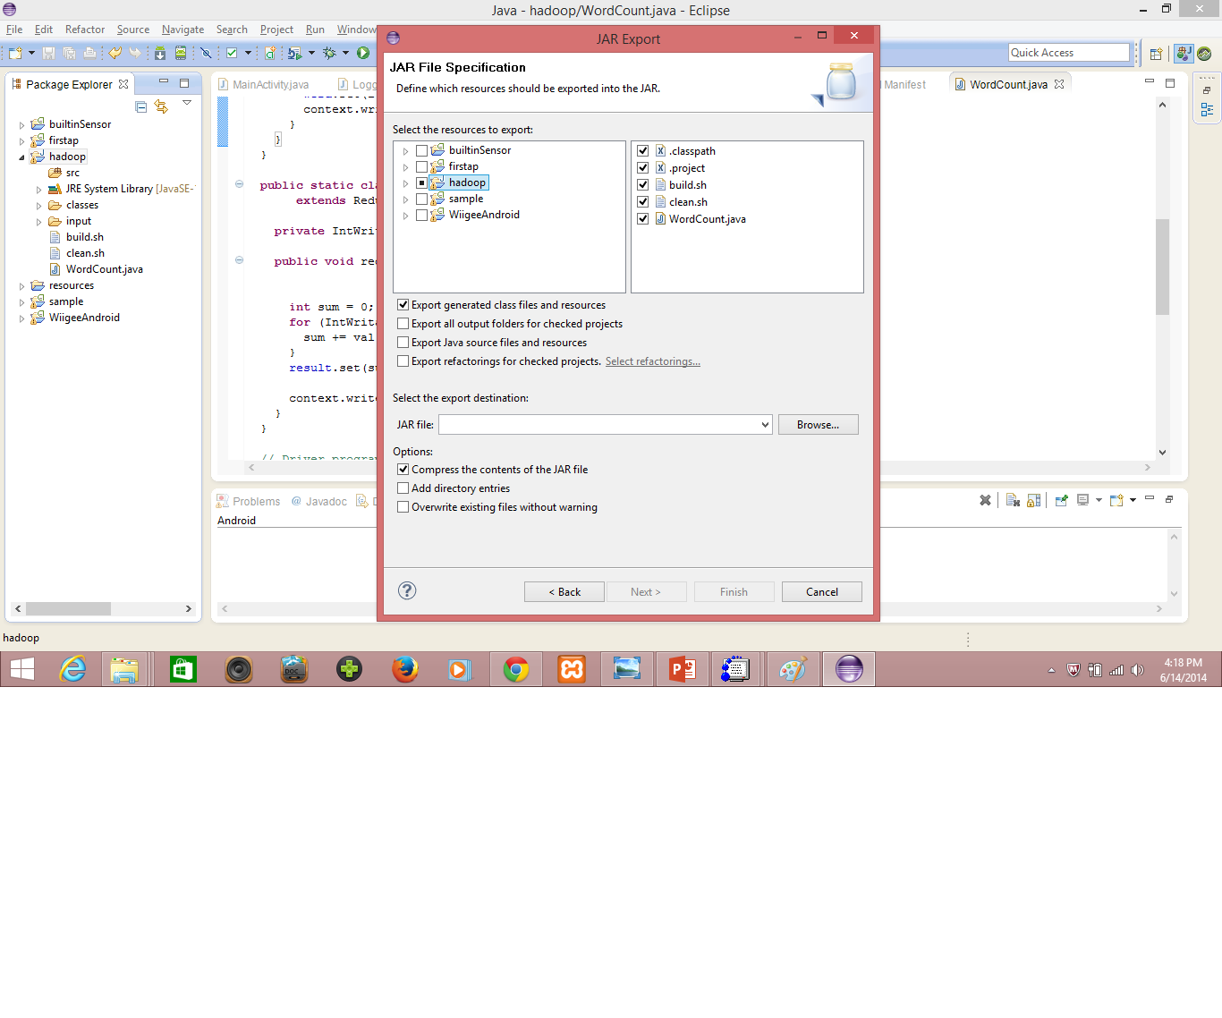

**TASK 3:**

**Create an account and deploy files to Github:**

Firstly signed up for the Github account as ‘tejasreesai9’ then created a new repository as **lab 01** inorder to upload my files for lab01 in to Github. Then downloadd the Github and then sync the files from the lapop o the Gitub accout then commit it.

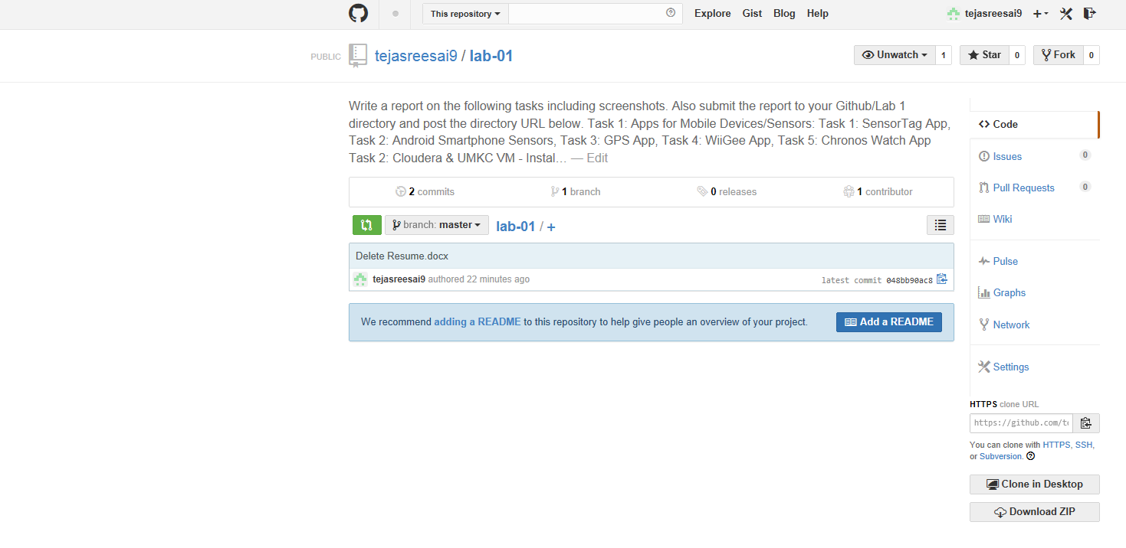

***Scrumdo Account Creation:***

Signed up to Scrumdo with the user name ‘tejasreesai9’ and then created a story with la 01 assignment’ and then defined the task to do in that story and he time when I has to be completed. The screenshots before and after the completion time are as below.

